Invoice Line and Vehicle model top count:

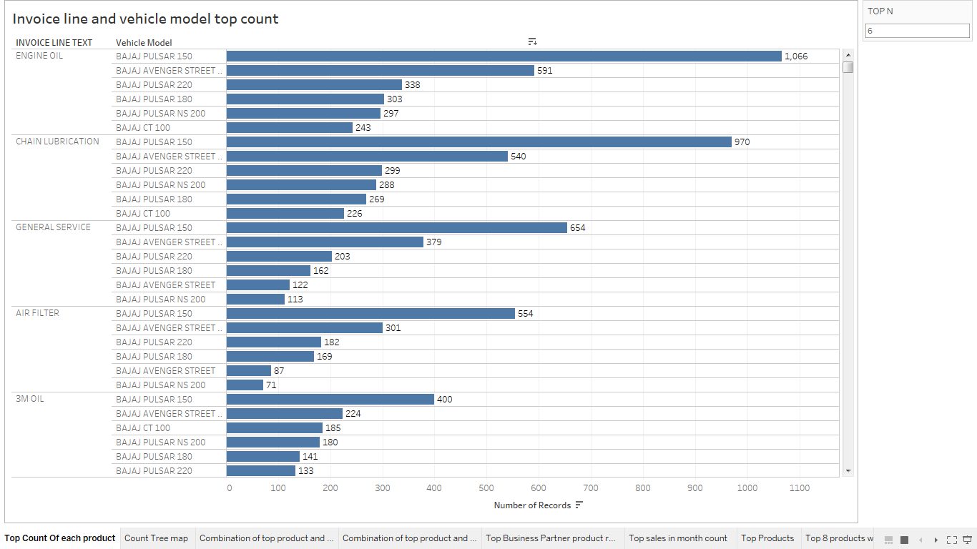

Count Tree Map(Combination of invoice line text and vehicle model):

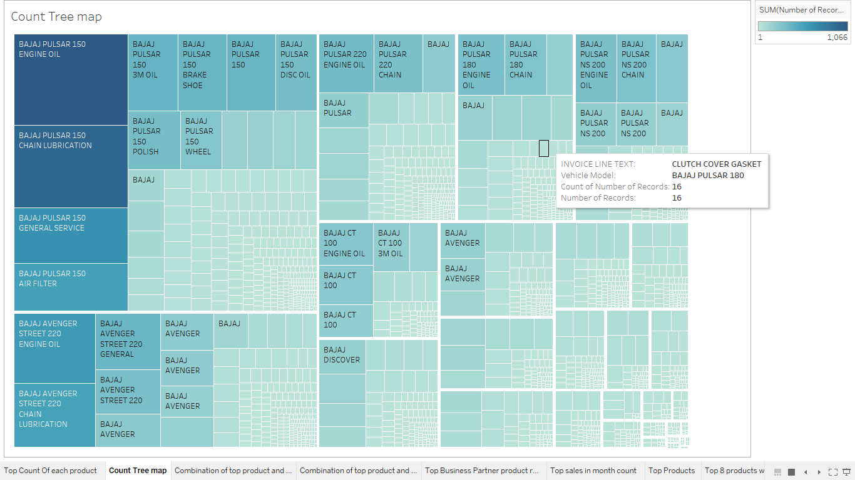

Top Combination products and vehicle model:

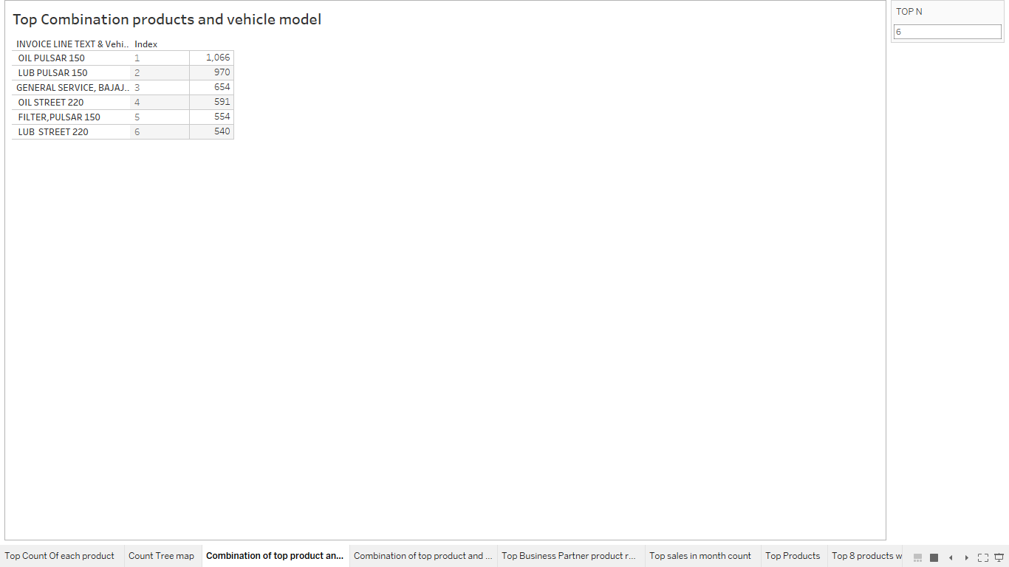

Combination of Top product and Vehicle:

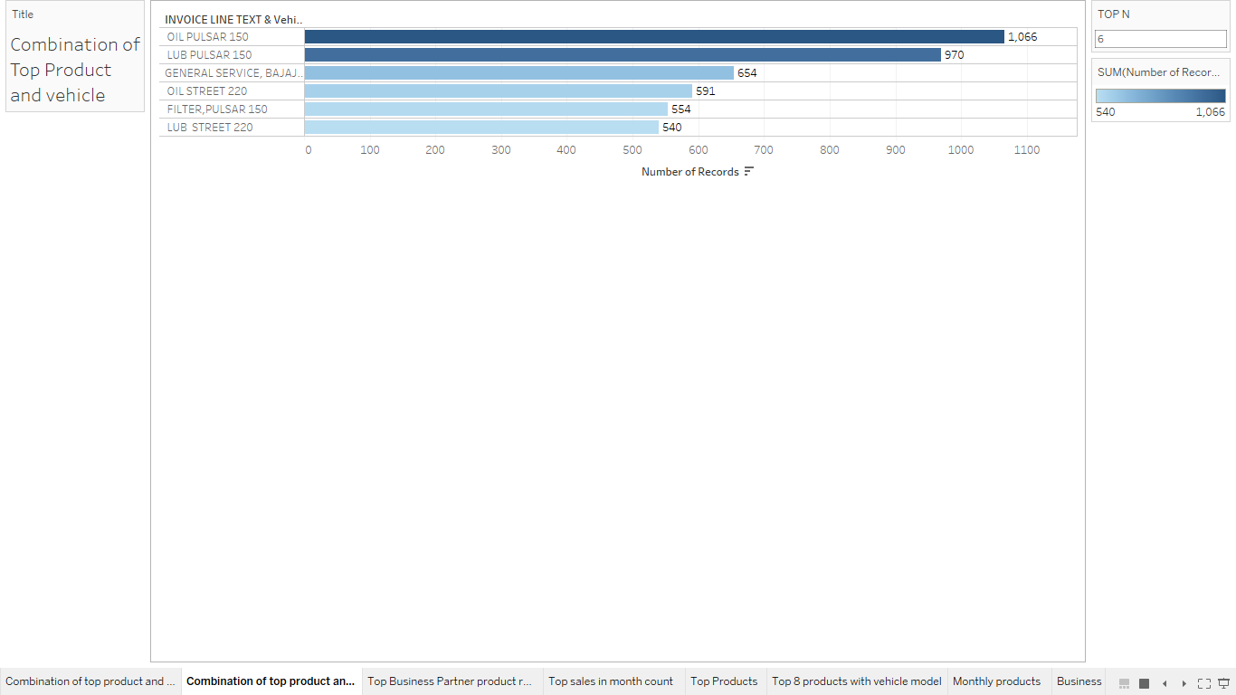

Business Parter(Vehicle model+Invoice line text):

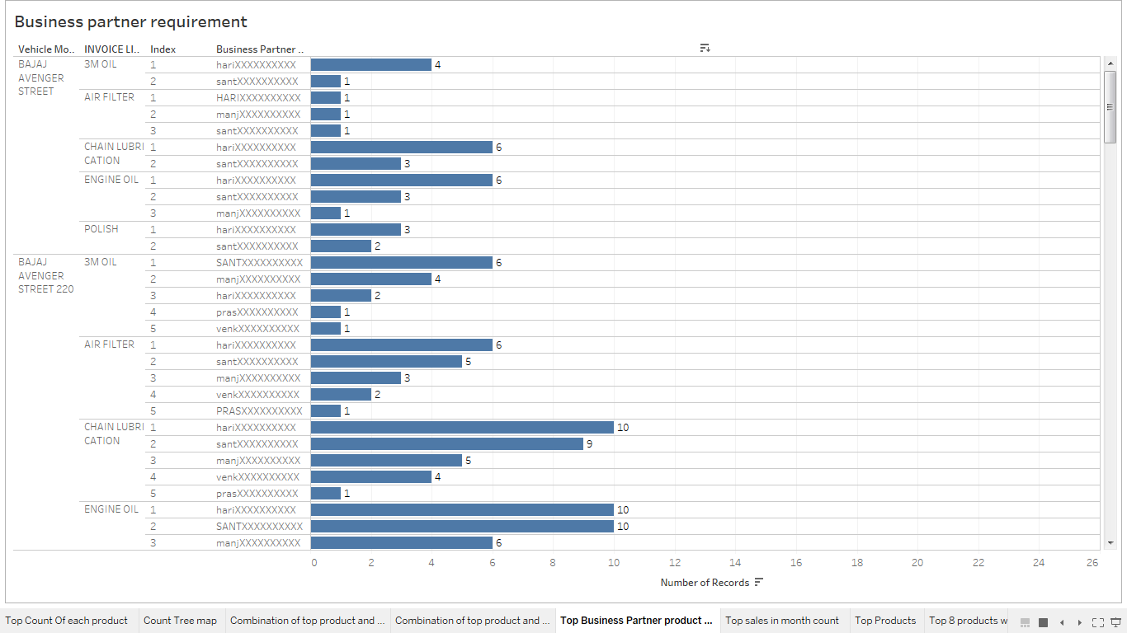

Sales of products:

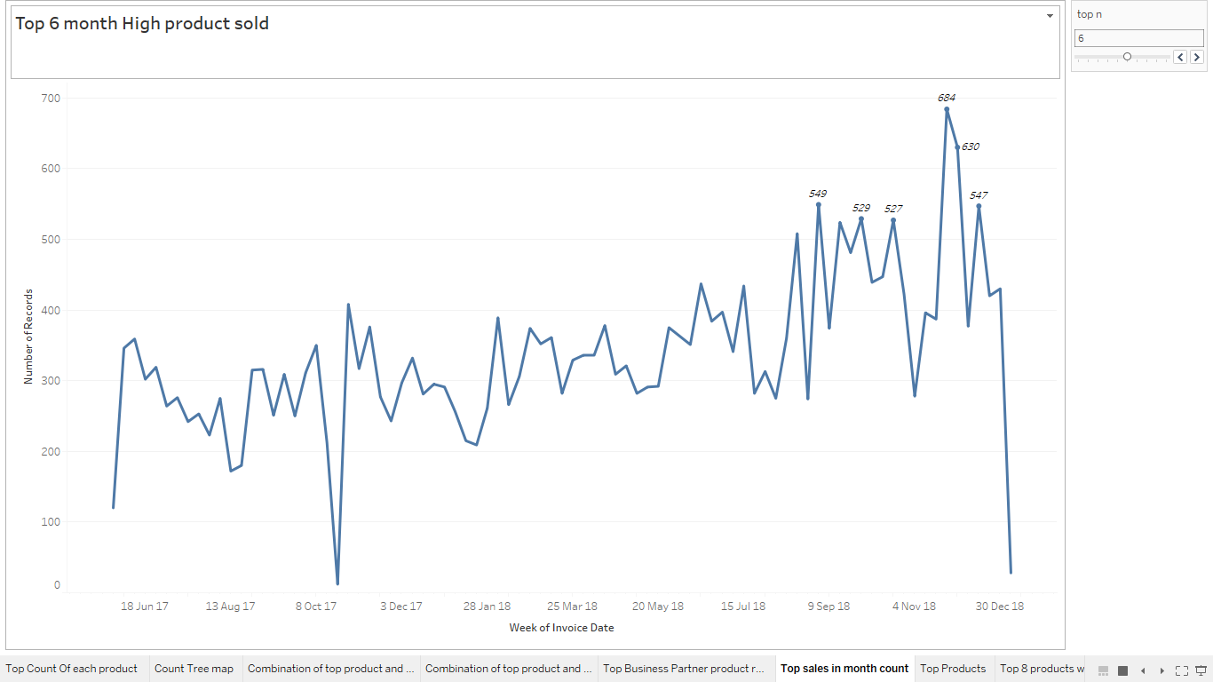

Top 10 Products:

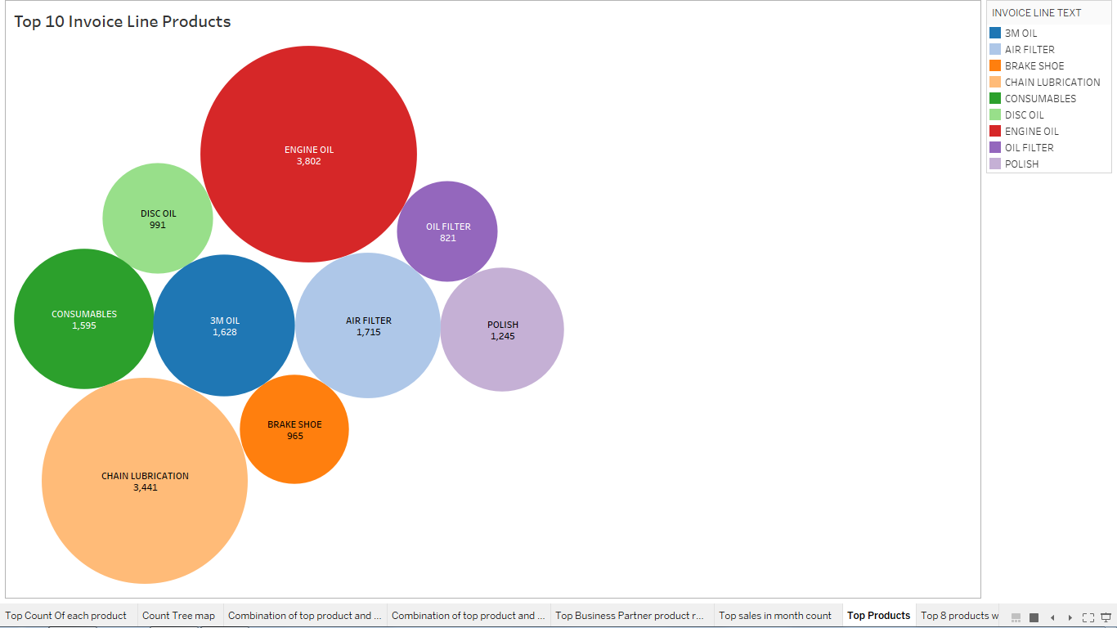

Stacked chart of vehcile model with top 10 products:

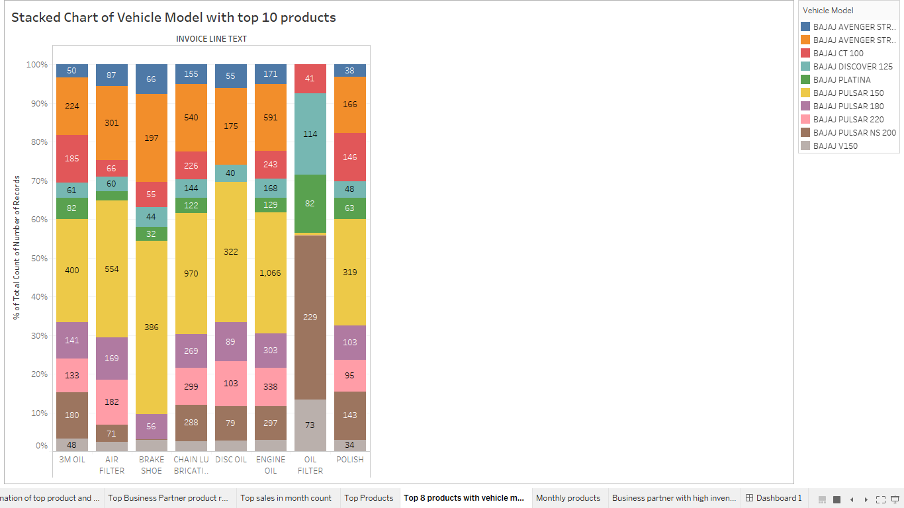

Dashboard and story:

